The Center for Public Service Psychiatry
Annual Conference
Western Psychiatric Institute and Clinic

Save the Date!
Monday, May 14, 2018
8:30 am to 4:30 pm
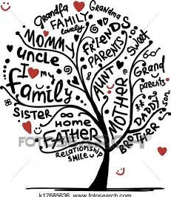

Beyond the Bars: Reducing the Impact of Incarceration on
Children and Families

Plenary Speakers:
Anna E. Hollis, Executive Director, Amachi Pittsburgh (Keynote)

Amy Kroll, Director of Justice Related Services, Allegheny County DHS

Kevin Jordan, CEO, Adaptive Behavioral Services, Inc.

Program:
Panel discussions featuring programs and resources from:
Community Advocates, Behavioral Health, Government and Corrections

Panelists will include: Children and Family Members with Lived Experience, Corrections Peers, and Leaders of Community, Government, Correctional, and Behavioral Health Systems

Elsie H. Hillman Auditorium, Hill House
1825 Centre Avenue, Pittsburgh PA

Who Should Attend
The conference is intended for all stakeholders of the behavioral health and correctional systems,
including certified peers, community advocates, service users and their families

This activity has been approved for AMA PRA Category 1 CreditTM

The University of Pittsburgh is an affirmative action, equal opportunity institution.

